|  |  |
| --- | --- |
| DAtabases  DBAS6211 | Assignment  Jabulani Sithabiso Dhludhlu  DBAS6211A1 |

**Question 1**

* **Database Management Systems**

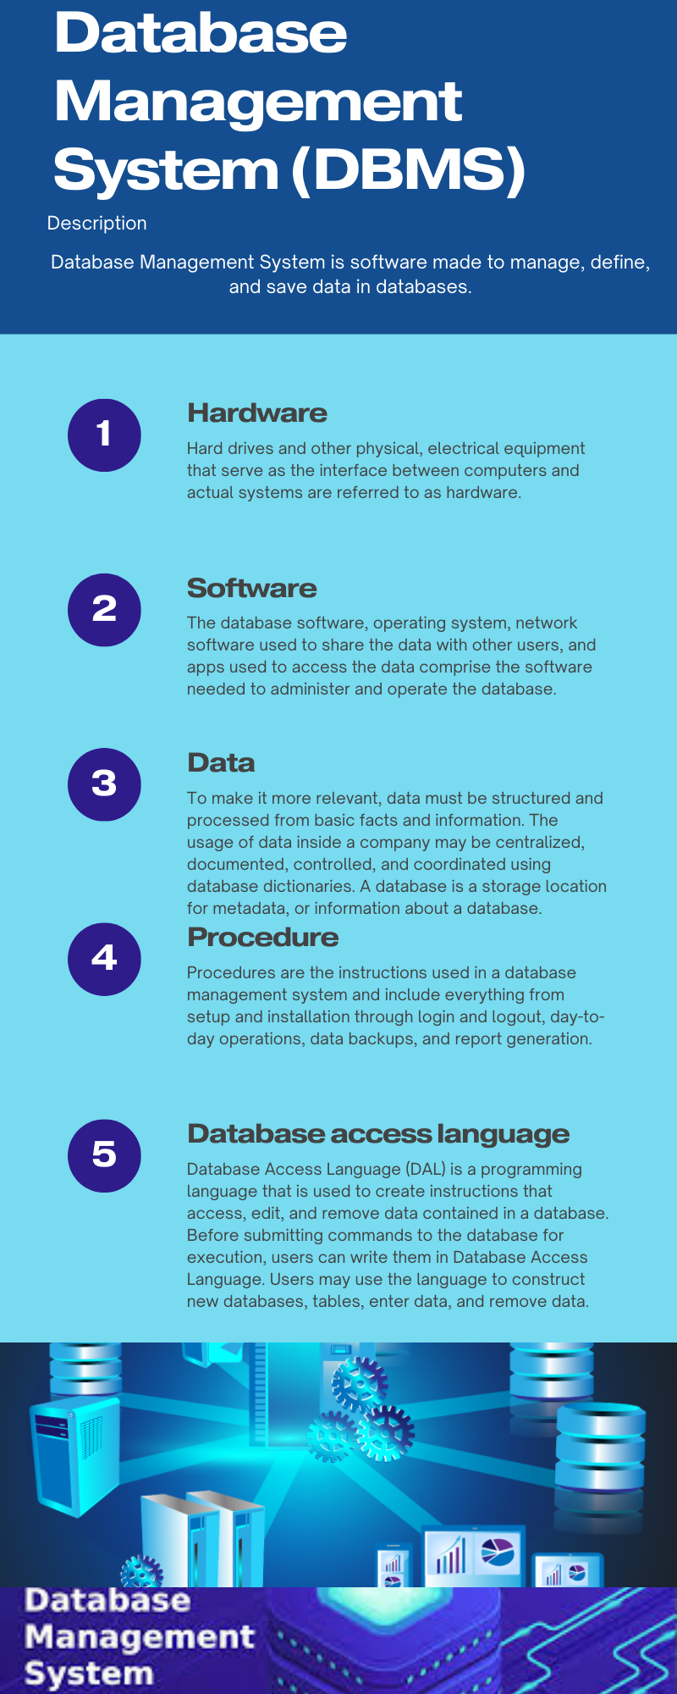

**Question 2**

1. **Relational**

* A relational database is a collection of information that organizes data in pre-set relationships. Data is kept in one or more tables of columns and rows, making it easier to view and understand how different data formats connect to each other. Relationships are logical connections formed between various tables based on their interaction.
* Benefits of relational databases
* The fundamental advantage of the relational database architecture is that it allows for an understandable representation of data and quick access to linked data points. As a result, relational databases are most typically employed by enterprises that require the management of vast volumes of structured data, such as inventory monitoring, transactional data processing, and application logging.

1. **NoSQL**

* NoSQL is a database management strategy that supports a wide range of data structures, including key-value, document, columnar, and graph formats. A NoSQL database is one that is neither relational, distributed, flexible, or scalable. Other common NoSQL database properties include the absence of a database schema, data clustering, replication support, and eventual consistency, as opposed to relational and SQL databases' conventional ACID (atomicity, consistency, isolation, and durability) transaction consistency. Many NoSQL database systems are open source as well. (Mullins, 2019)

**Question 3**

* **Entity Relationship Diagram (ERD)**

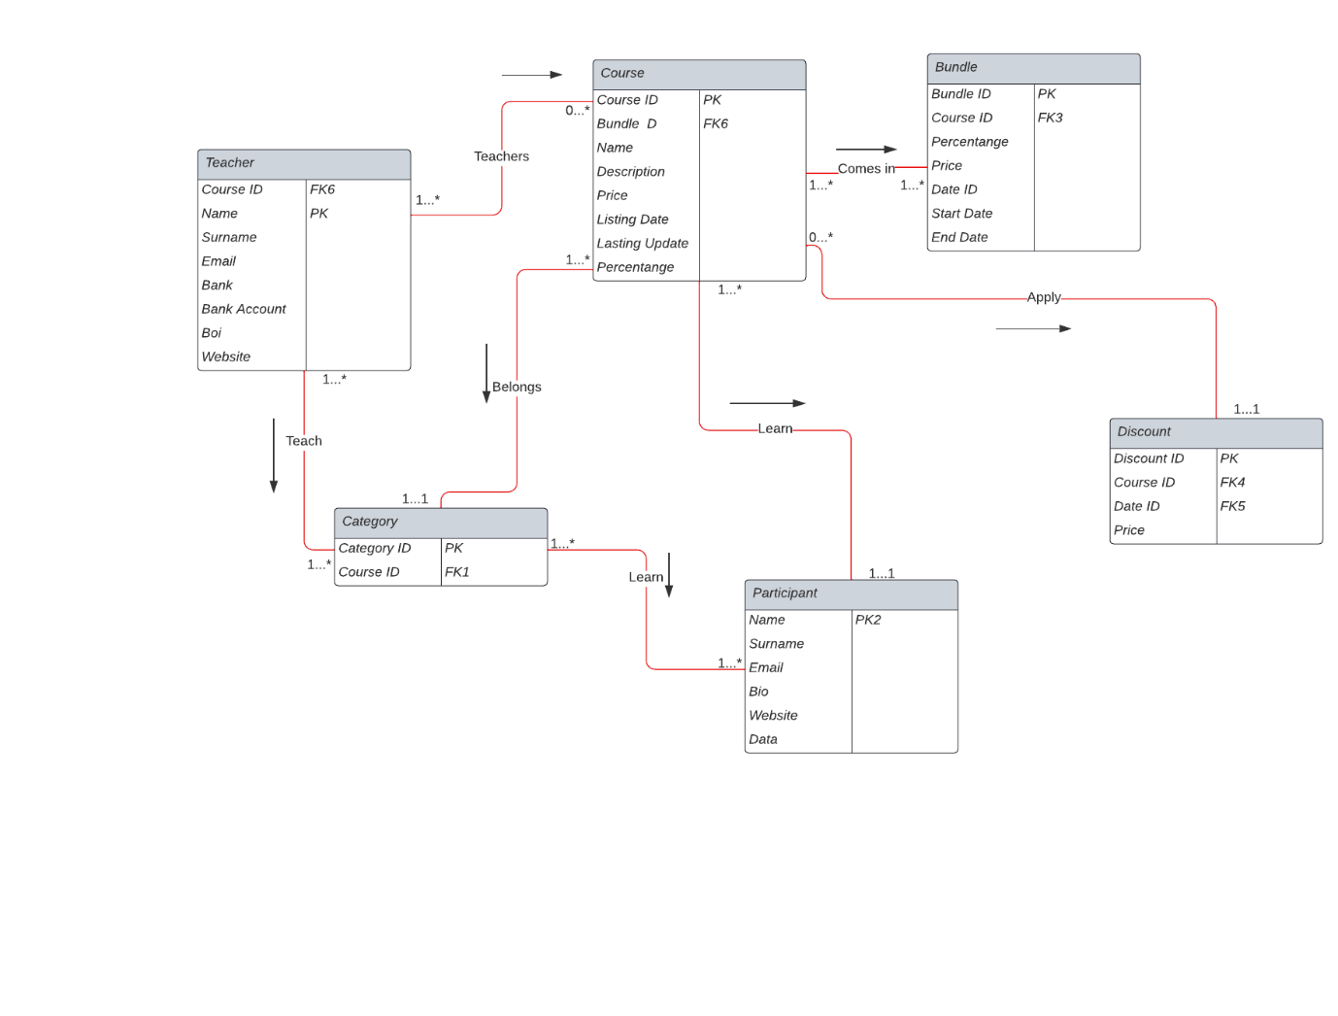

**Question 4**

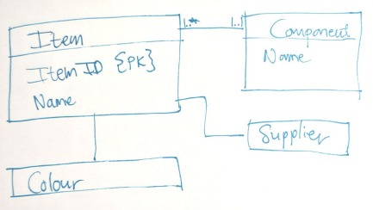

1. The quantity must be included in the components diagram.
2. For the provider, the provider’s name must be the primary key
3. The provider must be the object ID field and he should make it a foreign key because the provider can provide a specific object.
4. the color entity must have a foreign key and the itemID field must be added to the color entity.
5. There must be a link between the provider and the component.
6. connection between one and many
7. Include a box for address and name in the supplier diagram.
8. and the supplier's name make it the primary key. E. change the item's and supplier's connection to 0 to 1.
9. the color chart Make it the primary key by adding color.
10. in the color diagram, include Item ID as a foreign key.
11. Add an Item ID to the supplier and make it a foreign key.
12. Make the component the main key in the component box.

# References

Mullins, C. S., 2019. *NoSQL (Not Only SQL database).* [Online]   
Available at: https://www.techtarget.com/searchdatamanagement/definition/NoSQL-Not-Only-SQL  
[Accessed 14 April 2023].

Taylor, S., 2023. *Database.* [Online]   
Available at: https://corporatefinanceinstitute.com/resources/data-science/database/  
[Accessed 06 March 2023].